**Recruiting: Coding Exercise**

**Submitted By: Abdus Sakur**

**IDE: Visual Studio 2013**

**Language: C#**

**Database: SQL Server**

**Set Up Instruction:**

1. Download whole Project.
2. Double click on ClsLibraryMitchell.sln
3. Projects:

Class Library: ClsLibraryMitchell

WCF Web Service: WcfMitchell

Test Client (ASP.Net WebForm): TestClientMitchell

1. Run Project

**Architecture:**

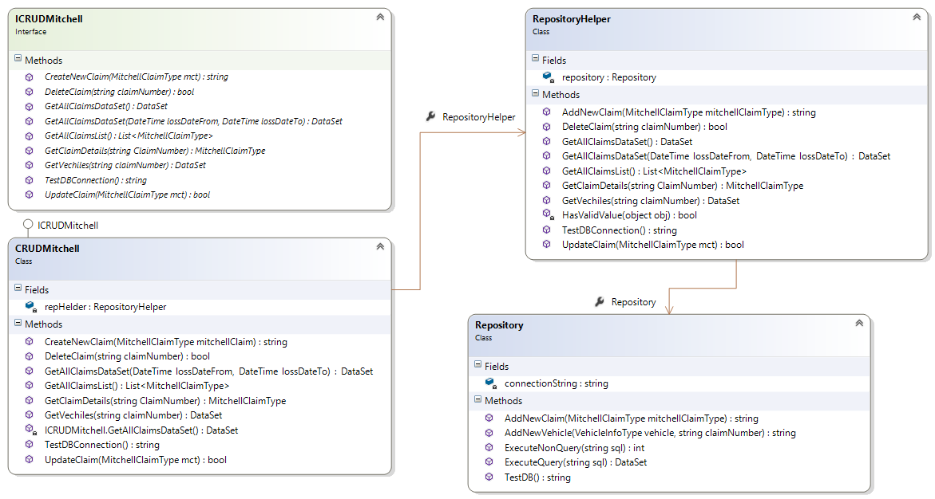

**Challenge**

Implement a Claims Web-Service (preferably in Java/C#) that performs the following CRUD operations. *A portion of the challenge is optional.*

1. **Create a claim and persist it to a backing store. The input to the create request should be a MitchellClaim XML.**

Webservice:

[OperationContract]

string CreateNewClaim(ClsLibraryMitchell.claMitchellClaim.MitchellClaimType mct);

Client:

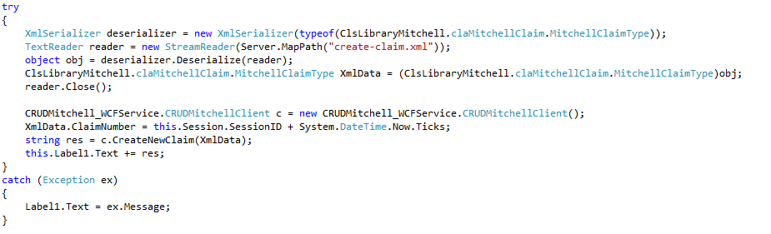

1. **Read a claim from the backing store.**

Webservice:

[OperationContract]

ClsLibraryMitchell.claMitchellClaim.MitchellClaimType GetClaimDetails(string ClaimNumber);

Client:

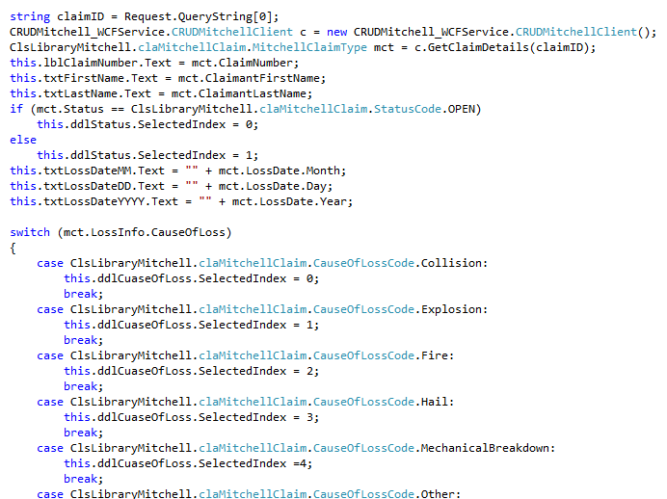

1. **Find a list of claims in the backing store by date range of the LossDate.**

Webservice:

[OperationContract]

System.Data.DataSet GetAllClaimsDataSet(DateTime lossDateFrom, DateTime lossDateTo);

1. ***[optional]* Update a claim in the backing store. The input to the update request should be a MitchellClaim XML. Only the fields provided in the input should be updated.**

Webservice:

[OperationContract]

bool UpdateClaim(ClsLibraryMitchell.claMitchellClaim.MitchellClaimType mct);

1. ***[optional]* Read a specific vehicle from a specific claim.**

Webservice:

[OperationContract]

System.Data.DataSet GetVechiles(string claimNumber);

1. ***[optional]* Delete a claim from the backing store.**

Webservice:

[OperationContract]

bool DeleteClaim(string claimNumber);

Client:

